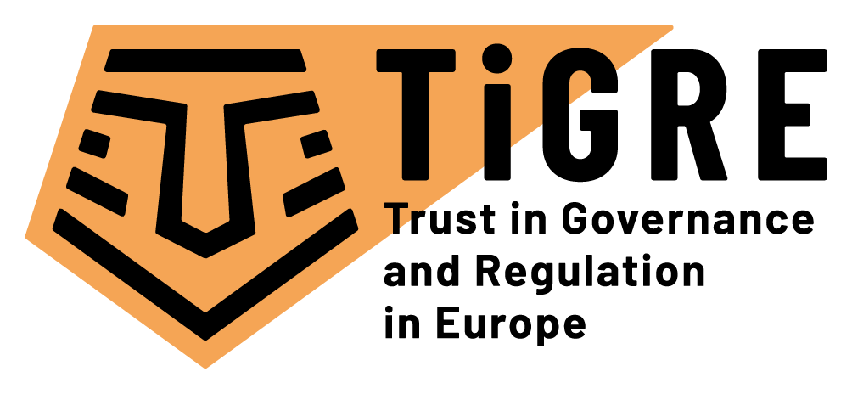

“Trust in Governance and Regulation in Europe” TiGRE project

Top-level international institutions to collaborate in the EU-funded project TiGRE for the analysis of trust relationships in European regulatory policies

The demands of citizens and public authorities for data and privacy protection, security and reliability of data and information, financial stability, product safety and traceability are constantly increasing. In such a context, all actors need to trust regulatory regimes that their interests are safeguarded. An optimal level of trust is a precondition and a consequence of well-functioning of regulatory policy making. This is exemplified by recent scandals, such as major data leakages and privacy-threatening behaviour by Facebook and Google for instance. Indeed, these scandals created threats for citizens’ trust in regulatory regimes, which operate across different levels of governance for carrying out regulatory policies. In this context, the analysis of trust relationships among a variety of actors involved in these regulatory regimes has thus become essential to draw a more encompassing picture of trust dynamics and understand their drivers as well as their political and socio-economic effects.
Funded by the European Commission’s Horizon 2020 research programme, the “Trust in Governance and Regulation in Europe” (TiGRE) project has the ambition to explore trust relationships in three high value sectors: Finance, Food Safety and Communication & Data Protection. It will analyse the conditions under which their regulatory regimes are trusted at different levels of governance such as regional, national and European. To that extent, TiGRE will examine how actors involved in regulation (such as administrative bodies, politicians, courts, firms, business, consumer groups and citizens at large) interact with each other. To achieve these goals and provide a comprehensive understanding of this phenomena, a variety of methods will be employed, such as questionnaires for large-scale surveys, case studies, focus groups, experimental studies and media content analysis among others. The TiGRE project partners will target and be in regular contact with European stakeholders, representing a broad range of regulatory actors. To connect research with policy and practice, the TiGRE project will provide indicators to detect signals of decreasing trust as well as scenarios on consequences of decreasing trust.

First-class academic expertise
Over the next 3.5 years, University of Lausanne (UNIL), with strong expertise in the study of multi-level governance and regulatory policies, will coordinate the TiGRE project with the help of SCIPROM. This interdisciplinary project will benefit from the expertise of 9 partner universities and research centres from 9 different countries:
- University of Lausanne (Switzerland)
- Antwerp University (Belgium)
- Aarhus University (Denmark)
- Hebrew University of Jerusalem (Israel)
- German University of Administrative Sciences (Germany)
- Kozminski University (Poland)
- Institut Barcelona d’Estudis Internacionals (Spain)
- University of Oslo (Norway)
- Utrecht University (The Netherlands).
Each partner will bring its own disciplinary skills, in political science, social psychology, law, economics, public administration and communication studies.

About Horizon 2020 programme
The project is framed under the challenge "Europe in a changing world - Inclusive, innovative and reflective societies", in the "Governance for the Future" section of the EU's Horizon 2020 programme. Horizon 2020 is the financial instrument implementing the Innovation Union, a Europe 2020 flagship initiative aimed at securing Europe's global competitiveness.

- More info on TiGRE: visit the TiGRE website at https://www.tigre-project.eu
- More info on H2020 programme: https://ec.europa.eu/programmes/horizon2020/

Contact
Project Office and General Enquires:
Dr. Kirsten Leufgen
SCIPROM Sàrl
+41216940412

Project Coordinator:
Ass. Prof. Martino Maggetti
University of Lausanne

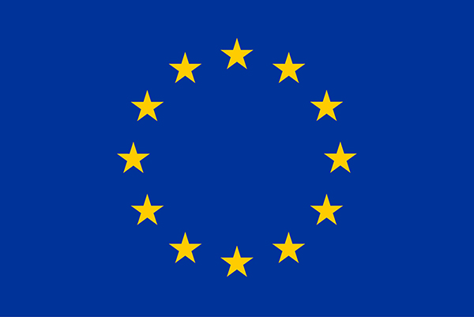
The TiGRE project has received funding from the European Union’s Horizon 2020 research and innovation programme under grant agreement No 870722 (TiGRE).

